The 3rd key to great web design

(The 3rd pillar of web design = UX & attention to details )

6.1. Introduction

UX & attention to details

The problem is attention to detail is nuanced. Its subtle. To the untrained eye its invisible.

222 better than 000

* Great design are great because of all these little thing that are add up.
* A brunch of little things = big improvement (individual ingredients in a cake are nothing but all made an amazing cake

UX:

1. Incredible complex topic;
2. I prefere to give you a crash course on it;

HACKS THAT’S PRODUCE SOLID RESULTS.

Don’t expect 10/10 in terms of UX. But you will be able to dramatically improve your designs!

6.2. What’s UX ? (Basics)

UI = user interface (aka our design )

Ex. A button designed in figma

UX = user experience (aka how our design work)

Ex. How the button works and how the user is supposed to use it to achieve a goal.

GREAT UI DOESN’T COMPENSATE FOR POOR UX

* The ketchup bottle could have a great design but is for nothing if that’s not useless and the ketchup spread on you.

Don’t upset the user ! 🡪 In real life we make compromises, in web design we don’t!

If you don’t care about UX, youre designing for likes ! “Fake designs” cost an arm and a leg to implement! WANT DRIBBBLE QUALITY ? PAY 50-100K !

6.3. The best example of good UX and attention to detail

When add to cart a product the page refresh and jump back to first category. That’s is a awful UX.

The platform was custom built on symphony modules

Prototypes done by clients are uncommon in Romania.

6.4. Improve the checkout process to double sales

Checkout improvement

3 distinct areas :

* Informatii si adresa
* Metoda de livrare
* Plateste comanda

Easier User experience/ no unnecessary clicks/ showing credit card icons

The user don’t appreciate the extra fractions

Transparency/ trust these are important. An easy way to check the total immediately.

6.5. Improve the mobile version to double sales

Check analitycs to see which is your best source of visiting your website

Do a lot of study and rise up your UX game.

Don’t try to design the perfect website ! Launch it as soon as possible and the client will come back with analitycs.

6.6. Seven websites tweaks that show attention to detail

1 - The “ add to cart “ button( adding a little “+” for each product because some people may assume that the button will take them to the cart

2 – Full image instead of cercles for each product including USPs (inside the image)

3 – Changing the body font  *Zilla Slab* instead of *Monito (a change based on statistics – it looks better on the mobile )*

4 – No separate tabs for presenting the product

5 – Highlighting a single review for each product (because generally people just leave a like or the review is not helpful

6 – Looking for influencers that could provide a quote for each product

7 – Change the live chat question before this said something like I'm here now. It says, “Can I help you ?” The service used for this is called “Chatra”

6.7. Upgrading the mobile product page

The things that make sense for desktop design are not the best for mobile design too

Fill the space effectively without having to scroll to much for “add to cart” button

6.8. Doing 1-on-1 session with a coder

Separate the type of work that’s being done.

For mobile version its more compact.

Setting up a local server for working to the website (a copy of the website) because we don’t want the website to be down while we are working at it.

This is sometimes called staging or sandbox mode.

What is Staging environment ?

A staging environment or staging site is a copy of your live website and is the last step in the [deployment process](https://umbraco.com/knowledge-base/deployment/) before changes are deployed to your live website.

By having a staging environment that is a copy of your live environment you are able to test new changes made by your developers before they are released to your live website. Using multiple environments is not necessary, but it comes with a long list of advantages, which are especially important if you work on big or complex projects.

Testing new changes on a staging environment before deploying them to your live website also reduces the risk of any errors or issues that will affect your users. This effectively means happier users and more uptime for your website.

Sandbox site

The Sandbox Site is an exact copy of what is installed with each new **[liveSite](https://livesite.com/buy)**. We created this sandbox site so you wouldn't have to start your new website from scratch and to provide an awesome place to play around with all the latest features or to evaluate if liveSite is right for you.

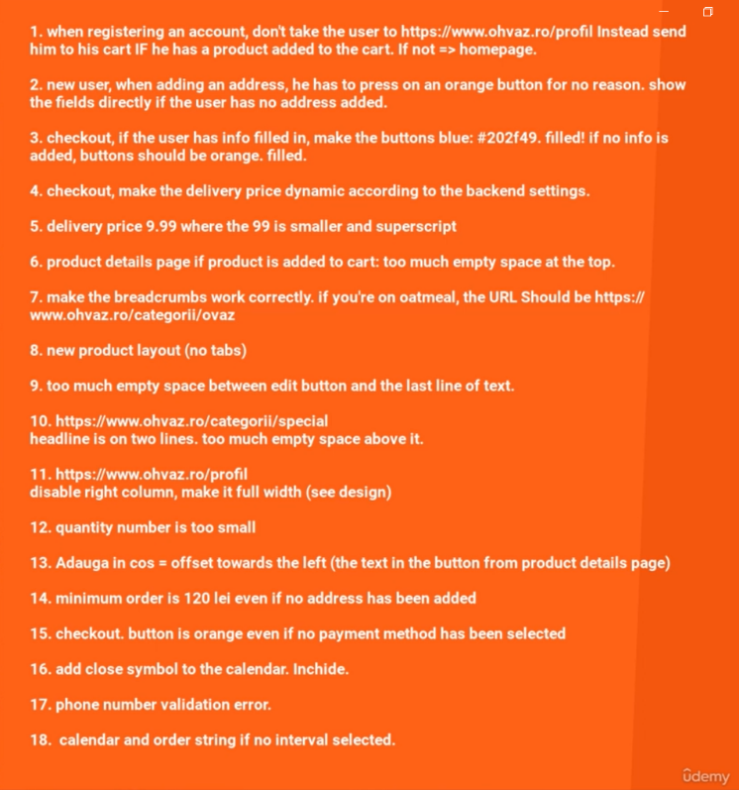

6.9. Here is what you need to remember

Invest passion in your projects

On one hand is matter of knowledge on the other hand is a matter of doing more than needed (attention to detail)